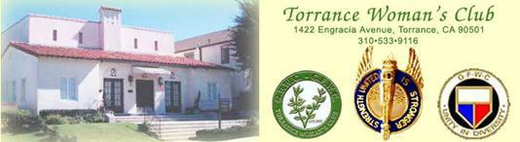

**Member**

**General Federation of Women’s Clubs - California Federation of Women’s Clubs - Marina District Serving the Community Since 1921 – 501(c)(3) Tax ID: EIN 33-0249000**

President-Lynn Robinson, 1st VP-Carolyn Pohlner, 2nd VP-Janice Petrosino, 3rd VP-Janet Payne, Recording Secretary- Betty Robertson, Corresponding Secretary-Deanna Hanson, Treasurer-Sharon Broadbent, Auditor-Lynda Myers, Ways and Means-Open, Program-Carolyn Pohlner, Press-Kathleen Davis, Yearbook-Open, Newsletter- Carol Woods, Reservation-Susan Warner, Parliamentarian-Open, Historian-Open, Directors-Madonna Davenport/Lee Large, Technology-Mary Alessandra-Cook

# JANUARY 2023 NEWSLETTER

**PRESIDENT ’S MESSAGE**

#### LYNN ROBINSON

Happy New Year! I hope you all enjoyed the holidays. Thank you all for your donations to the toy drive, “Be A Santa to a Senior,” Trinity Care Hospice, the DCFS coat drive and all the other charities we support. You made a difference in a lot of lives during the holiday season.

Here we are at the start of a new year. I ask you to look back at last year at TWC. Think about what you liked, didn’t like, wished we had done or wished we had done differently. Then think about this new year. What ideas and suggestions do you have? What are you willing to do for our club? When you are done thinking about it, **let the board know!** We need to hear from you in order to do the best job we can for you.

I’m looking forward to seeing what amazing things TWC will do in 2023!

# THANK YOU FROM CAROLYN

I want to thank all the women who participated in decorating and turning the Clubhouse into a beautiful venue for our Annual Holiday Boutique and Luncheon. From President Lynn and Annette Degner decorating the Christmas tree on the stage, to all the ladies who came in to decorate and adorn their individual tables so festively, the Banquet Hall’s transformation was completed by Lois Koza, Alberta Brice, and Ellen Jenkins. Thank you, ladies, for all your hard work!

We also need to thank all those women who crafted and baked and donated their goodies to the Boutique. There were so many beautiful and delicious items to choose from! The Holiday Boutique owes its success to those who contributed the items, as well as those who bought the items! Thank You ALL!

1

### TECHNOLOGY CHAIR IN THE CORNER

##### Mary Alessandra-Cook

This month’s technology tips are culled from an article sourced by *The Washington Post* and posted [on August 5, 2021](https://blog.ioaging.org/aging/5-life-enhancing-tech-tools-for-seniors/) by [*Institute on Aging*](https://blog.ioaging.org/author/ioadmin/)*. Rewritten and reformatted by* Mary Alessandra-Cook*,* TWC Technology Chair.

###### Life-Enhancing Tech Tools for Seniors

The older adult population continues to grow and therefore companies are developing technologies to make life easier for them. Many of the new tech advances did not exist 5 or 10 years ago. Here are a few of the favorite tech tools for today’s seniors that the Institute on Aging and The Washington Post have identified as useful for today’s seniors:

###### Device Locators

Keys go missing. Where are my sunglasses? Where did I leave my phone? We all have these issues and questions from time to time. Tech companies have come up with clever solutions to these problems. [Tile](https://www.thetileapp.com/en-us/) offers affordable Bluetooth trackers that can be attached to keychains or inserted into wallets for an easy find. [Apple](https://www.apple.com/shop/buy-airtag/airtag/1-pack?afid=p238%7CsyU1UIAS3-dc_mtid_1870765e38482_pcrid_516270124941_pgrid_116439818610_&amp;cid=aos-us-kwgo-pla-btb--slid---product-MX532AM%2FA) [AirTag](https://www.apple.com/shop/buy-airtag/airtag/1-pack?afid=p238%7CsyU1UIAS3-dc_mtid_1870765e38482_pcrid_516270124941_pgrid_116439818610_&amp;cid=aos-us-kwgo-pla-btb--slid---product-MX532AM%2FA) introduced its tracker designed specifically for iPhones. Then there’s the [Chipolo](https://chipolo.net/en-us/), which also has a nifty buzzing feature to alert you when you’ve left your keys behind.

###### Voice Controlled Appliances

Amazon’s Alexa, Google Home and Nest devices can do so much more these days than report on the weather or play music. Voice-driven technology is integrated into their appliances and plug-ins, enabling people to perform simple tasks such as turning lights on and off and shutting the blinds, to executing more complex tasks such as starting the washing machine, preheating an oven or making a cup of coffee. *(You can even command Google Maps by using your voice. Google Maps will be the subject of a future TWC Tech Tips column.)*

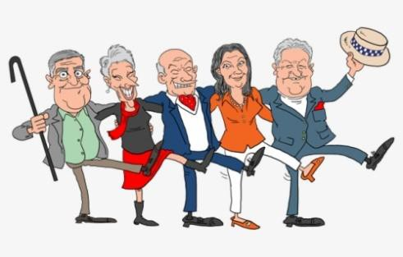

###### GPS Tracking Devices

Caregivers of individuals with Alzheimer’s or Dementia can feel more at ease if they can integrate GPS trackers into the elderly loved one’s life. These devices are tracking bracelets and watches such as the [Freedom Guardian alert watch](https://www.medicalguardian.com/medical-alert-systems/smart-watch-alert-app). Devices that can be inserted into clothing and pockets are made by [AngelSense,](https://www.angelsense.com/gps-tracker-for-elderly/?tap_a=14876-c779a9&amp;tap_s=240845-5da90b&amp;utm_source=affiliate&amp;utm_medium=ronnovak) and there are key chain based devices too such as the [PocketFinder.](https://pocketfinder.com/) One very clever wearable is the [SmartSole shoe insert](https://gpssmartsole.com/gpssmartsole/) which can be inserted discreetly into a shoe and is water- resistant.

###### Wearables for Pain Relief

With aging comes aches and pains, but tech companies are figuring out how to address that too. [Kailo](https://www.gokailo.com/) makes a wearable patch that uses nanotechnology to ‘fool’ the brain into thinking that the pain isn’t there. [Sports-Z DC stimulator](https://www.weartechit.com/) uses electrotherapy to promote circulation, healing, and muscle recovery.

###### Robotic Companions

Though it might sound far-fetched, having a robotic dog or cat as a low-maintenance companion can be beneficial. There’s [Buddy the Robot](https://buddytherobot.com/en/buddy-elderly-senior-robot-alone/), who can help seniors with reminders for appointments and deliveries as well as detect falls, and [Joy For](https://joyforall.com/) [All](https://joyforall.com/) companion pets that come in the form of fuzzy, lifelike kittens and puppies. These robots are not substitution for real human interaction of course, but studies have shown that these robots do help to ease loneliness and serve as a mood buster.

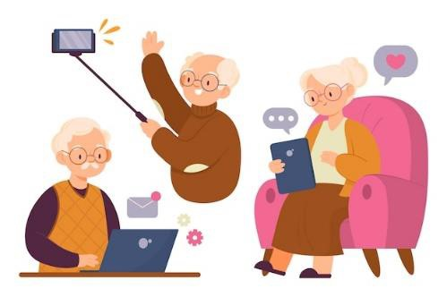

2

CRAFT CONTEST - Bette Herbst

The craft contest for all area clubs will take place January 20, 2023, at the Torrance Woman’s Club as part of the scheduled District Meeting. Craft items for the contest need to be at the club by 9 a.m. Each category will be judged for first and second place plus honorable mention. The craft contest items will be available for viewing after the general meeting. The winning entries will go home with Bette Herbst, art contest chairman. Entries not selected need to be taken home.

The winning entries will be on display at the April 22nd Convention, which is also being held at the Torrance Woman’s Club. Since there is no state competition this year, all art entries need to be taken home at the end of the day.

Paperwork, showing the crafter’s name and craft item, need to be filled out and brought to the January meeting. Contact Bette Herbst to obtain the appropriate entry form.

[bhollin115@aol.com](mailto:bhollin115@aol.com) or 310-375-6926 The craft item categories are:

* 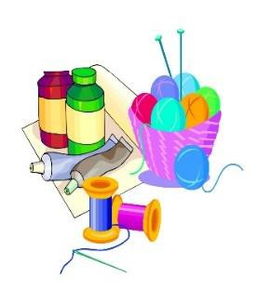Hand Quilting
* Machine Quilting
* Apparel Sewing
* Knitting
* Crocheting
* Weaving
* Other Needlework
* Counted Cross Stitch
* General Crafts

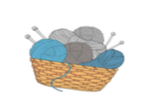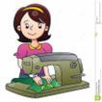

* Trash to Treasure
* Sculpture
* Glass

##### Rules for Craft Contest:

* Entries must have been created in the prior calendar year.
  + Complete the entry form for each category to be entered in the Craft competition and attach to the article.
  + Entries will be placed and judged in the category indicated by the entry form.



### HEALTH AND WELFARE

##### Anita Dinicola Tips for Seniors

Lots of people are out driving. The traffic seems

worse, the drivers seem rude, and disasters happen. Don’t be a fatality

Most stores have senior hours. You can go during that special time and not get shoved around. Don’t take a lot of cash. Know where your credit cards and money are. Take a family member or close friend with you, if possible.

Wear a mask in crowds. Wash hands often. Bring sanitary hand wipes or liquid sanitary solution.

Don’t over-do and get tired. Stop often if you need to and know your surroundings. Keep possessions close to you. Keep your phone where you can get it easily.

Get your flu shots and vaccine. Stay hydrated. Enjoy family and friends. Be happy. Be healthy.

3

### HELPING HANDS

##### Hildegard Graeber

Happy new year to all friends at the Torrance Woman's Club. We're busy with holiday activities, family and friends visiting, while we also work on the club reports. I'll give you a preview of Helping Hands' report, which gives me an opportunity to thank the many members who worked to accomplish this.

We made & donated 500 Huggy Bears, (240 to each hospital and 20 to Rainbow Services). This was due to Pat having cut out all the facial features, Joy doing the stuffing, Carol doing the facial inking, and Donna tying ribbons on them. After we were able to meet in person, we had more hands doing stuffing: Cherie, Beverly, Bonnie, Jeanie, Betty R., Carolyn, Sachi, Janice, Lois, Joy W., Connie, Susan, Charlie, Laurie, and Juanita.

We made and donated almost 100 cuddle quilts, half each to Rainbow Services and to Painted Turtle Camp. Those quilts were made by Bette H., Betty R., Lori S., and Linda B. I spent most of my time cutting & sewing Huggy Bears and turtles. Thank you very much to everyone who contributed! Hildegard

P.S. More "helping hands" are welcome at our next meeting on, Jan.18, 2023.

### INTERNATIONAL OUTREACH

##### Bette Herbst

Fifty bears from Helping Hands were mailed to a children’s hospital in Poland. The hospital refused to accept the package, so they were mailed back. We are now trying to find an orphanage

in the Ukraine that would like to have them.

# PROGRAM

#### Carolyn Pohlner

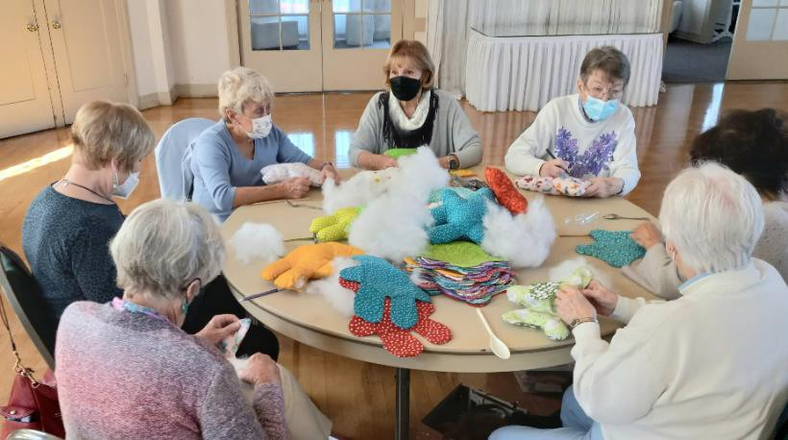The January 2023 Program will present Beth Wilson, Table Scaping Artist. Many of you will remember Beth from last year’s February program when she brought in her collection of Valentine’s Day handkerchiefs. This year she will entertain us by transforming one of our tables into a Winter Wonderland scene, with dishes, crystal, linens and decorations - all featuring a snowman theme. When she finishes decorating the table, it will be available in an opportunity drawing for one lucky TWC member to win! Included with the dishes, etc., will also be an $80 Gift Certificate from the Honey- Baked Ham Store. This multi-hundred-dollar prize can be yours for a $5 bid! Yes, that’s right - tickets for the drawing are only $5 each, or 6/$25! This is a fundraiser for our Club in lieu of the “Brown Bag” Drawing we have traditionally done every January. How much fun you’ll have setting a pretty winter table for your next dinner party, or Mah Jongg group!

|  |  |  |
| --- | --- | --- |
| **JANUARY CALENDAR**  Jan. 3, 10 a.m. Set up for tomorrow’s meeting  .  Jan. 4, 10 a.m. General Meeting 10a.m. Social Hour  11 a.m. Business Meeting  **Volunteer Forms due**  12 noon Lunch  1 p.m. Program  **“Table-Scaping”**  Jan. 13 Newsletter articles due  Jan.18, 10 a.m. Helping Hands Jan. 25, 10 a.m. Board Meeting  Jan. 26 Reservation deadline for February meeting  MARINA DISTRICT CALENDAR | **CHAMBER BUSINESS EXPO**  **Lynda Myers**  On Thursday, October 27th, 2022, our club hosted a table display at the Torrance Business Showcase. With over 100 businesses represented and 500 people in attendance the event was a success.  TWC is a member of the Torrance Chamber of Commerce. This year we decided to attend the annual business expo. With a simple display of our beautiful green tablecloth banner, yellow flowers, and give aways of candy mints, TWC pens, post it notes and club brochures. We enjoyed greeting the attendees AND seeing many friends.  Thank you to Mary Alessandra-Cook, Lois Koza, Carolyn Pohlner, Lynn Robinson and Betty Robertson for gathering, representing, chatting and mostly your dedicated fellowship as you graciously represented TWC at our booth. THANK YOU! Your time and talent are appreciated.  We gathered a handful of names of potential interest in either renting the clubhouse or becoming a | |
| Jan. 13 Marina Executive Board  Jan. 20 Marina District Council Mtg.  @ Torrance Woman’s Club Co-hosting w/ GFWC South Bay  Junior Woman’s Club | member. A lovely few hours out in the community.  For further information about the Torrance Chamber of Commerce visit their website. The host a monthly meeting the first Thursday of each month. As a member of TWC you are welcome to attend. | |
| JANUARY BIRTHDAYS   1. Theresa La Verne 2. Kathleen Davis   2 Jo Anne Weber  7 Annette Degner   1. Tina Olsen 2. Judith McCoy   11 Milli McFadden  16 Nuria Bustamante  16 Mary Varieur  22 Heidi Spangler  26 Mary Linn Coleman | 5 | **RESERVATIONS - Susan Warner**  Reservations for in-person attendance at our January 4th clubhouse meeting are due by Thursday, December 29th. Members in attendance at a regular monthly meeting will pay $20; take home meals will now cost $10. Please make your reservation with Susan Warner:  Telephone: 310-534-4092 Or  E-mail: [luvsapanda1@aol.com](mailto:luvsapanda1@aol.com) |

TREASURER’S R EPORT

Congratulations to the members of TWC for your excellent efforts in donations and fundraising. This is a listing of the charities that you have supported this year and a summary of the Window and Preservation funds.

# SET AND SERVE

Ladies, please consider signing up for set-up and/or decorations on Tuesday, January 3rd at 10 a.m. (the day before our meeting). Help with clean-up after our Wednesday meeting is also

|  |  |
| --- | --- |
| Donations to Charities - 2022 | |
| Bob Hope USO at LAX | $ 400.00 |
| Communities Child | $ 400.00 |
| Cup of Joe | $ 357.50 |
| Doors of Hope | $ 300.00 |
| El Camino College Foundation | $ 300.00 |
| FANHS | $ 300.00 |
| Fisher House of Long Beach | $ 700.00 |
| Friends of Madrona Marsh | $ 300.00 |
| Girls Love Mail | $ 200.00 |
| Guide Dogs of America | $ 300.00 |
| Heifer International | $ 400.00 |
| I Support the Girls | $ 382.70 |
| March of Dimes | $ 403.00 |
| Marina District - Art & Music Scholarships | $ 400.00 |
| Marina District - Birthday March | $ 100.00 |
| Member donations to DCFS | $ 1,835.00 |
| Trinity Kids | $ 1,315.48 |
| National Disaster Search Foundation | $ 300.00 |
| Operation Gratitude | $ 300.00 |
| Painted Turtle Camp | $ 300.00 |
| Rainbow Services | $ 403.00 |
| Ronald McDonald House | $ 300.00 |
| South Bay Village | $ 200.00 |
| St Jude Research Hospital | $ 553.00 |
| Starfish Project | $ 300.00 |
| The Attic | $ 300.00 |
| Torrance Arts Council | $ 300.00 |
| Torrance Civic Chorale | $ 300.00 |
| Torrance Historical Society | $ 100.00 |
| Torrance PD K-9 Unit | $ 300.00 |
| Torrance Rose Float Association | $ 700.00 |
| Torrance/Lomita Meals on Wheels | $ 400.00 |
| UNICEF | $ 1,100.00 |
| USDA Forestry Service-Penny Pines | $ 612.00 |
| Volunteer Center Food for Kids | $ 800.00 |
| Total | $ 15,961.68 |
| Window Fund | $ 14,452.27 |
| Preservation Fund | $ 28,692.91 |
| Total | $ 43,145.18 |

appreciated. The sign-up sheet will be on the back table, and you can always contact me directly. Lois Koza



# MEMBERSHIP

Happy New Year to all of you and we are off to a fresh start for 2023. The membership team has a few things planned for this year. In December four of our members decorated trees for the Festival of the Trees at Torrance Memorial. Jeanne Gilbreth and our camera-shy Betty Robertson decorated an opportunity tree. and Sharon Broadbent and I decorated an elf tree that sold for $2,000.00. We all had a great time.

Let’s make the year 2023 a great year for membership. The Torrance Woman’s has so much to offer to our members and our community.

Happy 2023 to all.

Janice, Mary Linn and Roberta

# ADVOCATES FOR CHILDREN

#### Gina Radicchio

Thank you, dear ladies, for all of your loving generously for the foster children. To date this Christmas season, we have donated over 1,400 diapers and wipes DCFS requested along with our continuing coat drive. We have delivered over 80 new coats and are still shopping and donating new coats. This worthwhile and needy project will continue through February. The much-needed coats are going out to the children as fast as I can get them to the social workers. It is a very emotional thing to see a cold child receive a much-needed coat.

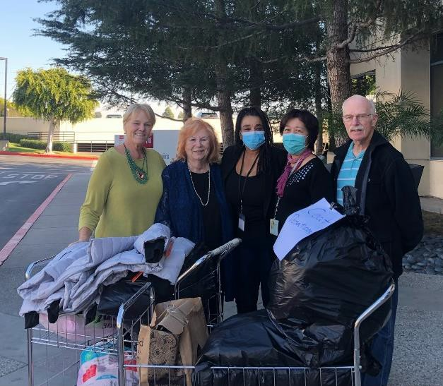Also thank you from my heart for your donations to children in hospice at Trinity Care Kids. Torrance Woman’s Club adopted 4 families which included 14 family members. Much needed gift cards from Target were given for needed items. The cards were wrapped in festive Christmas wrap and after Trinity Care Kids sealed the gifts social workers delivered them to the families. They are so happy and grateful. The social workers also said the families are still talking about the wonderful Easter baskets and how much they loved them. It is heartwarming to know we are bringing some happiness to very difficult lives. Thank you so much my dear ladies and God’s blessings to you. With love, Gina

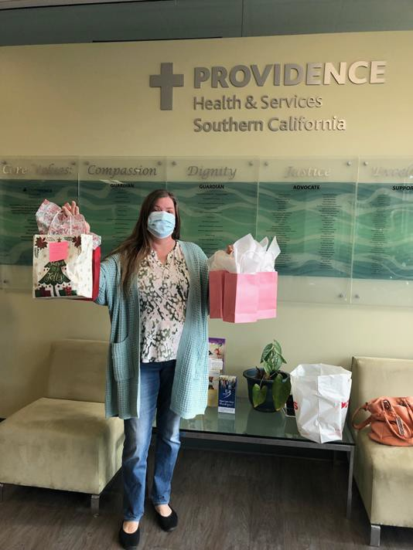 

***HAPPY HOLIDAYS***

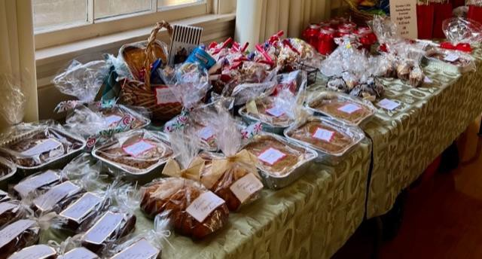

***There were lots of delicious baked goods.***

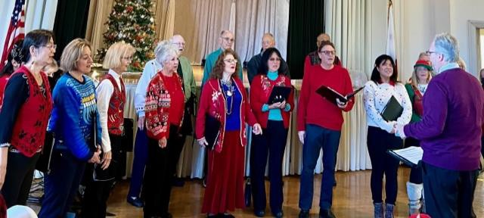***PROGRAM: Holiday songs by the City of Torrance Choir***

***Beautiful jewelry for sale***

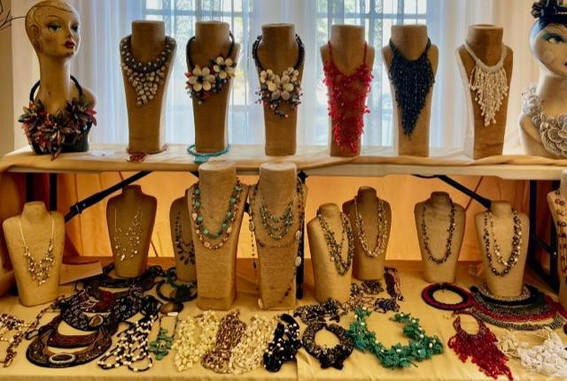

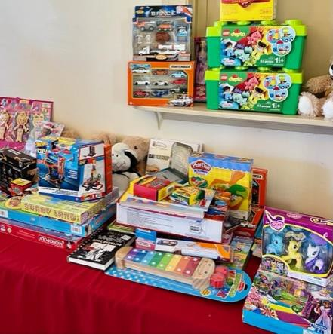

***Toy Drive for Torrance children.***

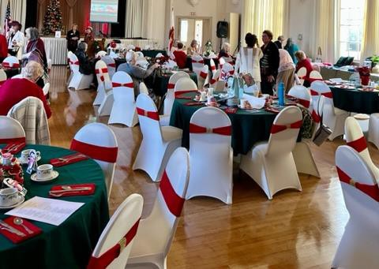

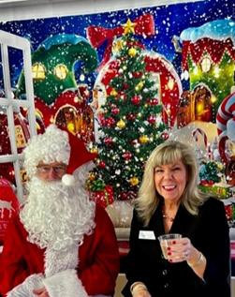***A visit from Santa****.* ***Tables set and decorated.***



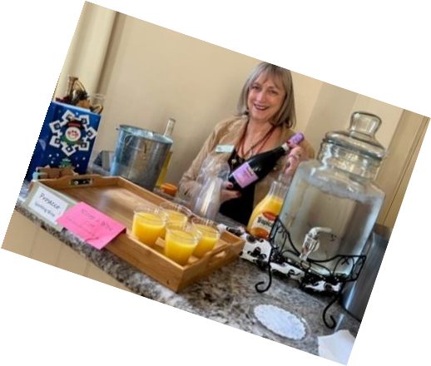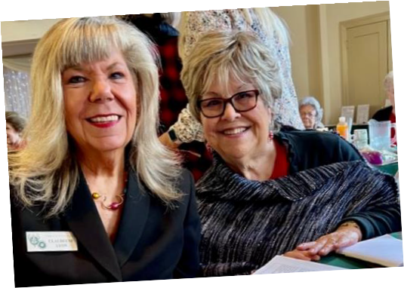

## New friends and old

## 

## Beautiful decorations

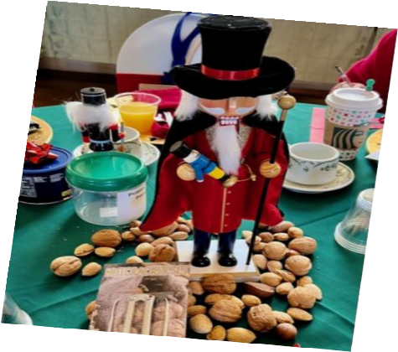

V

**Torrance Woman's Club**

**Annual Reporting - January 1,2022 to December 31, 2022  
Please complete description, hours, dollars and in kind.**

**NAME: _**________________________________

|  |  |  |  |
| --- | --- | --- | --- |
| ACTIVITY | DESCRIPTION | HOURS | DOLLARS |
| **COMMUNITY SERVICE PROGRAMS** | |  |  |
|  | | **ARTS** |  |  |
| Art Contest  Writing /Photography/ Crafts/ Music Contests  Torrance Civic Chorale/Local Theatre  Torrance Cultural Arts Foundation  Attend Concerts /Ushers  Torrance Rose Float  TMMC “Festival of Trees” |  |  |  |
|  | **CONSERVATION** |  |  |
| Paper Recycling  Green Recycling  Bottles, Cans, Etc.  Gardening  Other – “Pennies for Pines” |  |  |  |
|  | **EDUCATION** |  |  |
| Teacher's Aids  Book Club/ESO hours  Back Packs  Reading to Students  Donate Classroom Books  Donate to Local Libraries  Volunteer at Library  Dr. Seuss Books Other |  |  |  |
|  | **HEALTH & WELLNESS** |  |  |
| Hospital Volunteers  H.E.L.P. Volunteers  Fitness  “Girls Love Mail” notecards  Torrance EXPO  Immunizations - COVID, Flu Shots  Mammograms    Operation Gratitude” – Crocheted hats, scarves, greeting cars“Girls Love Mail”/ Other |  |  |  |
|  | **INTERNATIONAL OUTREACH** |  |  |
| Other- Huggy Bears to Poland |  |  |  |
|  | **CIVIC ENGAGEMENT & OUTREACH** |  |  |
| Service Dog  “Cup of Joe”  “I Support the Girls” |  |  |  |

|  |
| --- |
|  |
|  |
|  |
|  |
|  |
|  |
|  |
|  |
|  |
| - ■ |
|  |
|  |
|  |
| - ■ |

|  |  |  |  |
| --- | --- | --- | --- |
| USO - Toiletries, See’s Lollipops  Military - “Operation Gratitude”  Police Department  Fire Department-Holiday Toy Drive  Other Civic Activities |  |  |  |
|  | **SPECIAL PROJECTS** |  |  |
|  | **DOMESTIC VIOLENCE** |  |  |
| Volunteer/Donations- “Doors of Hope”  Toiletries |  |  |  |
|  | **ADVOCATES FOR CHILDREN** |  |  |
| “Buddy Benches”  DCFS -  “Food for Kids”/Volunteer Center  ECC Warrior Food Pantry  “Helping Hands”  “Helping Hands”  /Other |  |  |  |
| **COMMUNICATIONS & PUBLIC RELATIONS** | |  |  |
| Newsletter- Writing monthly articles  Individual Community Activities |  |  |  |
|  | **LEADERSHIP** |  |  |
| General Meetings  Board Meetings  District Meetings  District Officer  District Chairman  CFWC Officer  CFWC Chairman  Historic Preservation Committee  TWC Officers  TWC Committees  Other |  |  |  |
| **LEGISLATION & PUBLIC POLICY** | |  |  |
| Other - November 2022 Voting |  |  |  |
|  | **MEMBERSHIP** |  |  |
| Processing New Members & Introduction  Mentoring New Member(s) /Other |  |  |  |
|  | **WOMEN'S HISTORY & DEVELOPMENT** | | |
| Other | | | |
|  | **FUNDRAISING** |  |  |
| Fashion Show  Holiday Bazaars  “Brown Bag Auction”  Fundraisers  Ralph’s Donations/See’s Candy Fundraisers  Other |  |  |  |

**Annual Reporting - January 1,2022 to December 31, 2022  
(Continued)**